Coyotes in (insert city) .
Answers to the most common questions about coyotes
Q. Is what I am seeing a coyote?
Q. Are coyotes only gray in color?
Q. Aren’t coyotes only found in rural areas?
Q. Where did these coyotes come from?
Q. Will a coyote kill my cat?
Q. Will a coyote kill my dog?
Q. What about attacks on people?
Q. Then what do coyotes eat?
Q. Why does there seems to be a large increase in the coyote population around me?
Q. Do coyotes hunt in packs?
Q. Is it unusual to see a coyote out during the daytime?
Q. Do coyotes interbreed with dogs?
Q. What are my options for dealing with coyotes if I don’t want them around?
Q. Where can I find some additional information?

Q. Is what I am seeing a coyote?
Some of the major characteristics to look for are a bushy black-tipped tail and overall gray appearance. Often coyotes get referred to as wolves, however there are no wild free-ranging wolves in Ohio.
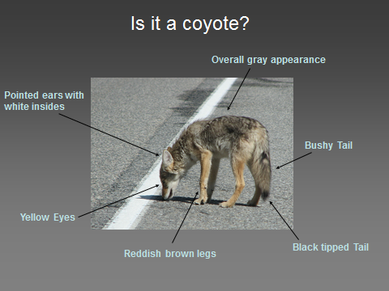
Q. Are coyotes only gray in color?
No. Coyotes can come in many colors as seen below. However the black-tipped tail will almost always be present and all coyotes will have the yellow eyes.
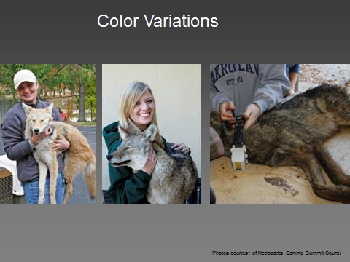
Photos courtesy of Metroparks, Serving Summit County
Q. Aren’t coyotes only found in rural areas?
No. Coyotes can be found throughout Ohio and are even a common inhabitant of cities.
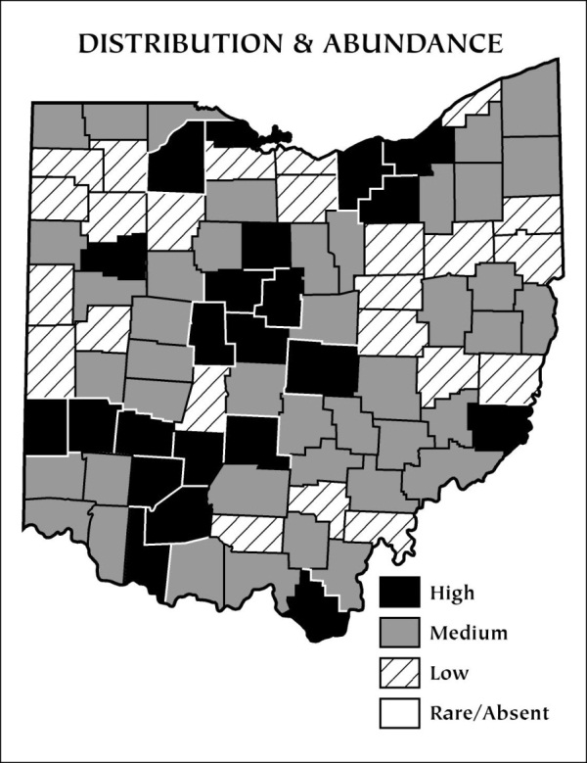
Data from the Ohio Division of Wildlife
Q. Where did these coyotes come from?
Coyotes were not reintroduced into Ohio. Starting in the early 1900’s, coyotes started expanding their range likely due to the loss of other predators in the Eastern United States. As they came into the Midwest, some went north into Canada and expanded to the North of the Great Lakes while others expanded range south of the Great Lakes. The first documented coyote in Ohio was in 1947 in Preble County however they may have been present in Ohio as early as 1919.
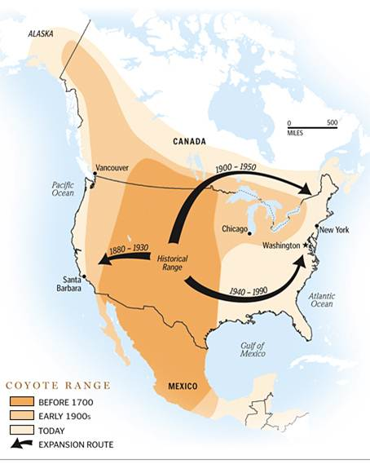
From: www.urbancoyoteresearch.com

Q. Will a coyote kill my cat?
While it is certainly possible for coyote-cat interactions to occur, there are ways to help avoid them. A study by Stubbs and Krausman (2009) looked at coyote-cat interactions in Tuscon, AZ. Over a three month survey there were 36 interactions with 19 resulting in the cat being killed. In one interaction, the cat even chased the coyote off. However, 31 of the 36 (86%) of the interactions were between sunset and sunrise. The best way to keep your cat safe is to ensure that that it is indoors before sunset and that you leave no cat food or water bowls out overnight.
Q. Will a coyote kill my dog?
Coyotes do not typically look to kill dogs. Most coyote-dog interactions occur when the dog is off leash and chases the coyote. In some rare cases, female dogs in heat left outside during the breeding season in February may be of interest by male coyotes for potential breeding. The best way to keep your dog safe is to keep it on leash when you are outside with it. Remember, there is a leash law in Ohio. Also, most adult coyotes weigh between 25 and 35 pounds and they seldom weigh more than 45 pounds. You can see below that even a cocker spaniel weighs the same or more than a coyote. Coyotes typically will not look to take on a dog larger than itself, viewing it as a fight they will not win. Even small dogs often prove to be too much of a hassle for coyotes to deal with.
Q. What about attacks on people?
Coyote attacks, especially in the Eastern US, are very uncommon. Conover in Resolving Human-Wildlife Conflicts found that annually there are only 2 coyote attacks on people in the US with zero fatalities. Comparatively he noted that humans are over 300 times more likely to get attacked by a skunk than a coyote. In Northeast Ohio there has only been one documented “attack” on a person. The interaction occurred in the Chagrin Reservation in the early 2000’s when a coyote ran up to a biker and bit his leg. However, that coyote was quickly trapped and consequently tested positive for rabies. No known, verified attack has occurred by a healthy coyote in Northeast Ohio on a human. However, you should treat ALL wildlife with respect and remember that they are all wild animals. In addition, you should never intentionally feed coyotes.
Q. Then what do coyotes eat?
A coyote’s diet mainly consists of small rodents. Gehrt (2006) evaluated coyote feces in Cook County, IL (Chicago area) and found 42% of their diet comprised of small rodents. While 22% of their diet consisted of deer, the majority of that is due to coyotes taking advantage of road killed deer. Coyotes will feed on any type of road kill they can find. Also, a large portion of their diet consists of vegetative matter such as fruits and grasses.
Q. Why does there seems to be a large increase in the coyote population around me?
The data from the Ohio Division of Wildlife suggests that the coyote population overall in Ohio is stabilizing. However, coyotes will move around and occupy new areas for several reasons. It could be that some younger coyotes are dispersing from their mother’s home range in the Fall. It could also be that your area has an abundant source of rodents upon which they can feed. If you have bird feeders, it is a good idea to make sure all bird seed is cleaned up off of the ground daily to lower the number of rodents around your home.
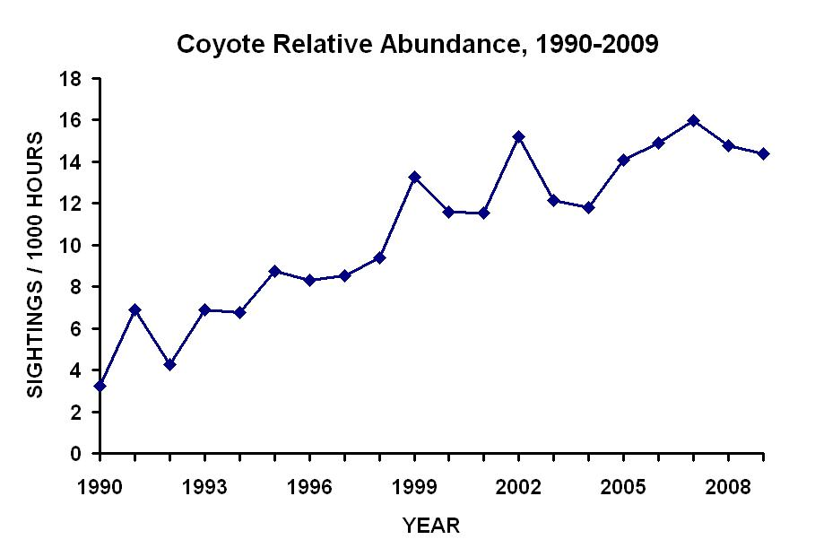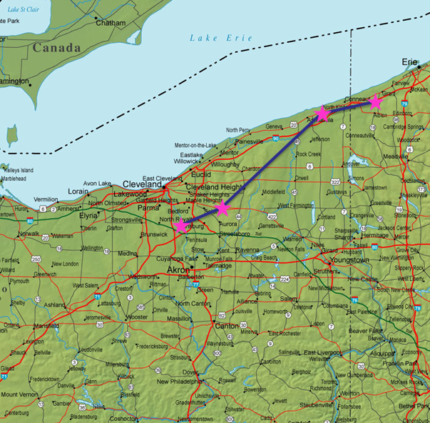
Data from the Ohio Division of Wildlife Dispersal of a coyote in Metroparks, Serving Summit County study
Q. Do coyotes hunt in packs?
No. Coyotes live in family units usually consisting of only 5-6 coyotes. This family unit is made up of two adults and the young from the previous year. However, one major difference from their cousin the wolf is that coyotes are solo hunters. The only time you may see multiple coyotes hunting together is when the mother is teaching its pups how to hunt. However, even in these situations there is no coordinated attack.
Q. Is it unusual to see a coyote out during the daytime?
Coyotes have learned to adapt to city living very well. Especially in the Spring and Fall you will regularly see coyotes out during the day. In the Spring they are spending more time looking for small rodents to feed the pups. In the Fall the previous years’ pups are forced to leave and look for areas unoccupied by other coyotes. Because of their great adaption to cities, they regularly hear doors slamming, dogs barking, people talking, etc. So, they get used to those noises when they are out moving around. This is much like living next to a railroad. Over time you get used to the noise of the trains going by. It is normal behavior for them to pay no attention to people. A good rule-of-thumb is that a sick coyote will look and act sick. They will have hair loss, stumble when they walk, or continously approach and/or growl at people. If you notice any of these situations notify the police department immediately at ___(insert PD number here)____.
Q. Do coyotes interbreed with dogs?
While biologically it is possible for coyotes and dogs to breed and produce offspring (called coydogs), the occurrence is not common. A study conducted by the Ohio Division of Wildlife in the 1980’s found an occurrence rate of only 2% statewide. It is likely that most of these were in rural Ohio where it is much more common for dogs to be allowed to run freely on a landowner’s property.
Q. What are my options for dealing with coyotes if I don’t want them around?
Coyotes are here to stay. Even if they are all removed from an area, other coyotes will move in to occupy the newly voided area. However if you need to address a specific problem with a specific coyote, the following are your options:
1) Contact the city animal control officer at __(insert number)__ for assistance. IF THIS IS AN OPTION WITHIN YOUR CITY
2) There is an open season for trapping coyotes. In urban setting snares can work very well to catch coyotes and no trapping license is required for you to trap on your own property.
3) You can have a friend, relative, or neighbor trap them for you for free. However, on your property they will need to have both a hunting and trapping license from the Ohio Division of Wildlife (http://wildlife.ohiodnr.gov/hunting-trapping-and-shooting-sports/hunting-trapping-regulations/trapping-regulations).
4) There are nuisance trappers that can do the trapping for you for a fee. Because you are paying them, the response time is usually very quick. There is no set fee, therefore it is encouraged to get price quotes from several trappers. A list of available nuisance trappers can be found at: http://wildlife.ohiodnr.gov/portals/wildlife/pdfs/licenses%20&%20permits/CNWACO%20Current%20License%20Holders.pdf.
5) The Ohio Division of Wildlife has an agreement with the Ohio State Trappers Association where they will provide trappers free-of-charge to trap coyotes if needed. However, since it is a free service, be respectful that the trapper is under no obligation to do the trapping and they are not required to rush out and set the traps. If you wish to contact one of these trappers, a list can be found at: http://www.ohiostatetrapper.org/ohiotrappers.pdf.
6) If you need additional technical advice, the Ohio Division of Wildlife’s Akron office can answer any questions, call 330-644-2293 Monday-Friday from 8am-5pm.
Q. Where can I find some additional information?
1) http://www.dnr.state.oh.us/Home/species_a_to_z/SpeciesGuideIndex/coyote/tabid/6598/Default.aspx
2) www.urbancoyoteresearch.com
3) http://www.summitmetroparks.org/NatureInformation/Coyotes.aspx
4) http://www.clevelandmetroparks.com/Main/Featured-Animal-Eastern-Coyote.aspx#coyote_role
