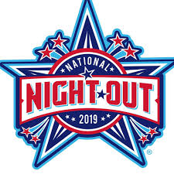

TUESDAY AUGUST 6TH 1200 JAKSE DRIVE
6-9 PM EASTLAKE

FLASHLIGHT WALK AT 9:00 PM

OPEN SWIM 7:15 – 8:45
BOUNCE HOUSE – DJ- HOT DOGS-WATER
COTTON CANDY & SLUSHIES

FREE ADMISSION!! EVERYONE WELCOME!!
QUESTIONS?? CALL RUTH MARSHALL 440-951-1400 EXT. 1128

